Praful Jotangia



## ~ Mid Management Professional ~

[prafuljo@yahoo.com](mailto:prafuljo@yahoo.com)

+91-9833341127

# Career Timeline (Since

Expertise in blending creative intellect and sharp planning skills for managing business operations and meeting top & bottom-line objectives, targeting senior level assignments in **General Management, Facility and Vendor Management Location Preference:** Mumbai / Gujarat.

# Profile Summary

**Key Skills**

General Administration Facility Management Vendor Management

Budgeting & Cost Optimization Audits & Compliance Management Program/Project Management Govt. Liaison

HSE Management Leases

* A goal-oriented professional with **nearly 15 years of experience** in **General Administration and Facility Management**
* Extensive experience in **general administrative activities**, personnel management, policy implementation and facility management across assignments

## In-depth knowledge of Asset Management, Liaisoning – Complainces, Housekeeping & Security Operation, Cafeteria & Pantry Services, Guest House Management, Inventory & Record Management, Travel Desk and Front Desk, Stationery, Pest Service, AMCs,

* Skilled in managing a wide spectrum of administrative activities including **material procurement, Infrastructure – Renovation or expansion, Vendor development, budgetary control and outsourced annual service contracts**
* Experienced in management of **facility expansions and development of new facilities** with effective manpower management skills to manage the work with limited number of human resources
* Effectively managed as per business teams to **meet the needs of market, sustained a positive & committed organization culture and ensured appropriate professional & personal development** of staff team members
* An effective communicator with relationship management skills with the capability to relate to people at any level of business and management across the globe; possess excellent negotiation skills

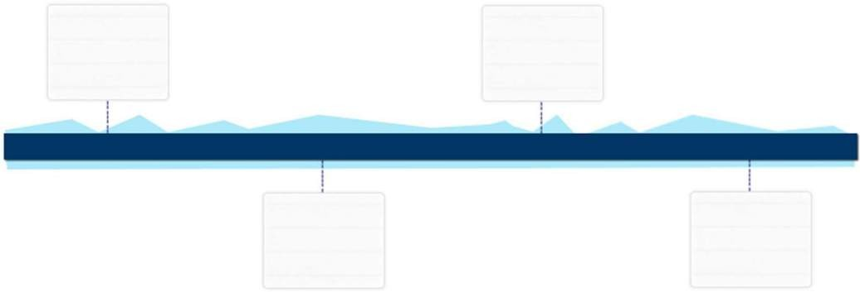

Pvt. Ltd.

Andheri East

# Work Experience



**Academic Details**

B.Com. from University of Mumbai in 1992

P G Diploma in Management – Business Administration from L N Welingkar in 2019

**IT Skills**

MS Office (Word &Excel)

Tally 5.4, EMS portal

**Personal Details**

**Date of Birth:** 26th April 1972 **Languages Known:** Gujarati, Hindi, Marathi,English

**Address:** Flat No. 204/A, Dahisar Saraswati CHSL, C S Road No 4, Dahisar East Mumbai -400068.

**Since March’2007 with Intertek India Pvt Ltd, Powai East as Assistant Manager – Administration**

## Key Result Areas:

* + Delivering high quality and courteous facilities management services in support of business needs within the safe working environment
  + Providing 24X7 facilities & administration support across the department; guiding the Operations Team (within admin) by promoting best business practices
  + Executing the financial analysis of Expansion/Renovation projects or lease thereby preparing the recommendations for the Management Team
  + Developing long-term partnerships with suppliers; managing day-to-day supplier performance to ensure meeting of service, cost, delivery and quality norms
  + Monitoring the entire functions of building facilities including pantries, wash rooms, common areas and taking appropriate action
  + Coordinating with suppliers /AMC Vendors regarding AMC, PO, Review and processing invoices,
  + Following health & safety action plan and work towards **achieving 0% health & safety issues**
  + Participating in development, implementation, evaluation & modification of administrative as and when required as per HO requirement
  + Supporting in Implementing new policy/ process or revisiting existing policy / process wherever required by HO
  + Maintaining Record management, Courier, Fleet Management, AMC for AC, DG, Fire Panel, Housekeeping, Security, Pest Control, Fire Extinguishers, Printed and office stationery or many more

# Previous Experience

## Profile : Credit Control – client - VSNL/ Tata Teleservices

**Follow up with**

2005 – 2007

Duraline India Pvt Ltd, Mumbai as Credit Controller

**Profile Multi tasking profile**

1994 – 2005

MX Electronics, Mumbai as Office Executive in account department

1992 – 1994

Maheshwari Pragati Mandal, Mumbai as Office Executive - Trade directory project